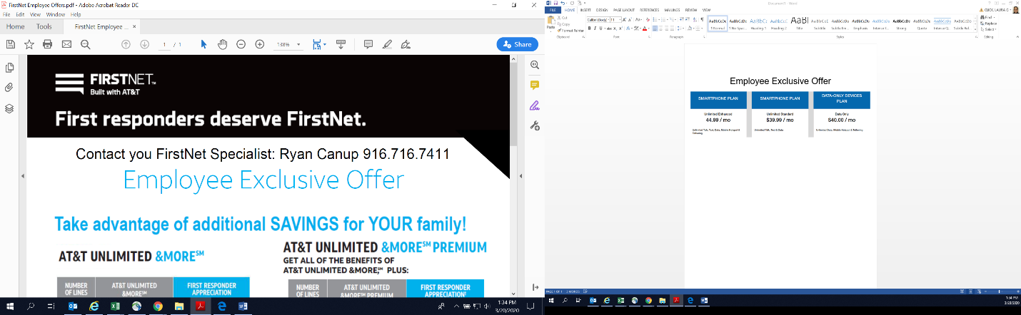

|  |  |
| --- | --- |
|  | |
|  |  |

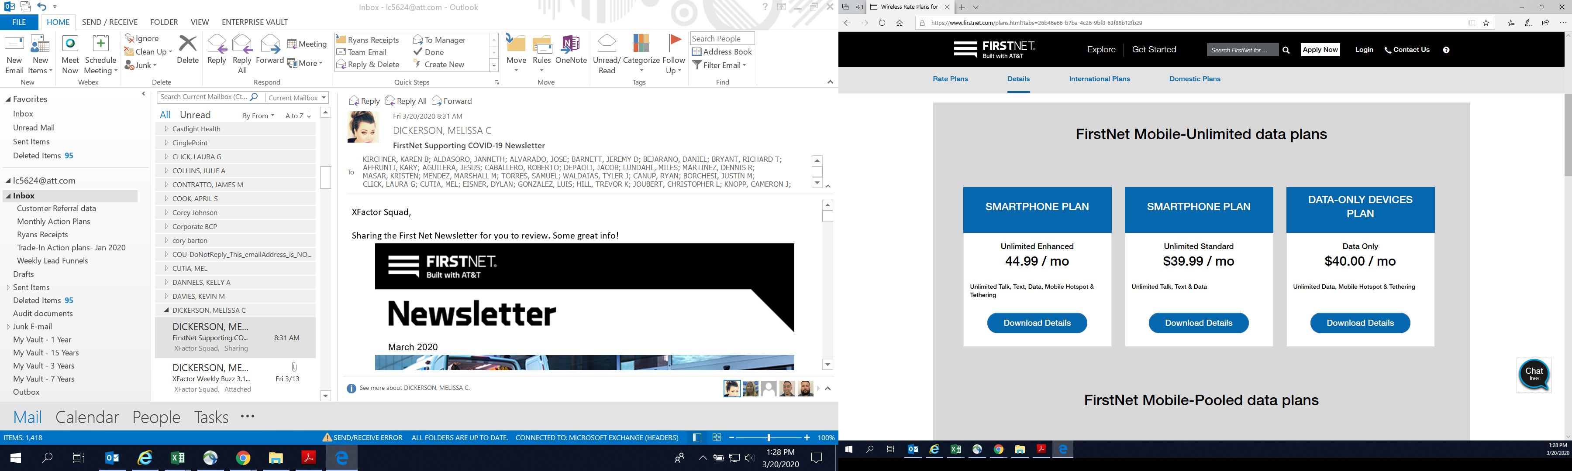



First Responder Appreciation Offer

Unlimited Elite Plan:

|  |  |  |  |
| --- | --- | --- | --- |
|  |  | Estimate w/o Auto Pay/Paperless Billing | Estimate with Auto Pay/Paperless Billing |
|  | Line 1 | ~~$95~~ $71.25 | ~~$85~~ $63.75 |
|  | Line 2 | ~~$170~~ $127.50 | ~~$150~~ $112.50 |
|  | Line 3 | ~~$210~~ $157.50 | ~~$180~~ $135.00 |
|  | Line 4 | ~~$240~~ $180.00 | ~~$200~~ $150.00 |

Unlimited Extra Plan:

|  |  |  |  |
| --- | --- | --- | --- |
|  |  | Estimate w/o Auto Pay/Paperless Billing | Estimate with Auto Pay/Paperless Billing |
|  | Line 1 | ~~$85~~ $63.75 | ~~$75~~ $56.25 |
|  | Line 2 | ~~$150~~ $112.50 | ~~$130~~ $97.50 |
|  | Line 3 | ~~$180~~ $135 | ~~$150~~ $112.50 |
|  | Line 4 | ~~$200~~ $150.00 | ~~$160~~ $120 |

Unlimited Starter Plan:

|  |  |  |  |
| --- | --- | --- | --- |
|  |  | Estimate w/o Auto Pay/Paperless Billing | Estimate with Auto Pay/Paperless Billing |
|  | Line 1 | ~~$75~~ $56.25 | ~~$65~~ $48.75 |
|  | Line 2 | ~~$140~~ $105 | ~~$120~~ $90 |
|  | Line 3 | ~~$165~~ $123.75 | ~~$135~~ $101.25 |
|  | Line 4 | ~~$180~~ $145 | ~~$140~~ $105 |

To take advantage of this offer contact **Cameron Knopp** at 916-291-4735 email at ck028c@att.com

d